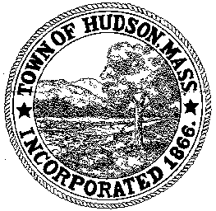

CONSERVATION COMMISSION
78 Main Street, Hudson, MA 01749
(978) 562-2020

Paul Byrne, Chairman W. Minot Wood, Vice Chairman David Esteves, Member

Terrence Joyce, Member Leif Longtine, Member Joseph Rodrigues, Member Al Tashian, Member

Meeting Agenda
March 3, 2011 7:00 P.M.

- Preliminaries
  - Open Meeting
  - Roll Call

2.0 New Business
2.1 Amendment to Order of Conditions
DEP 190-0510
Location: 258 Washington Street
Applicant: Bohler Engineering
Project Description: Construction of a 4,515 Square foot Hogan Tire Center on a parcel previously considered for Starbuck’s

3.0 Old Business

4.0 Correspondence

5.0 Adjournment:

Next Meeting: March 17, 2011

